Easy Read – Privacy Notice
Who we are
We are the Devon Domestic Abuse Alliance (DDAA).
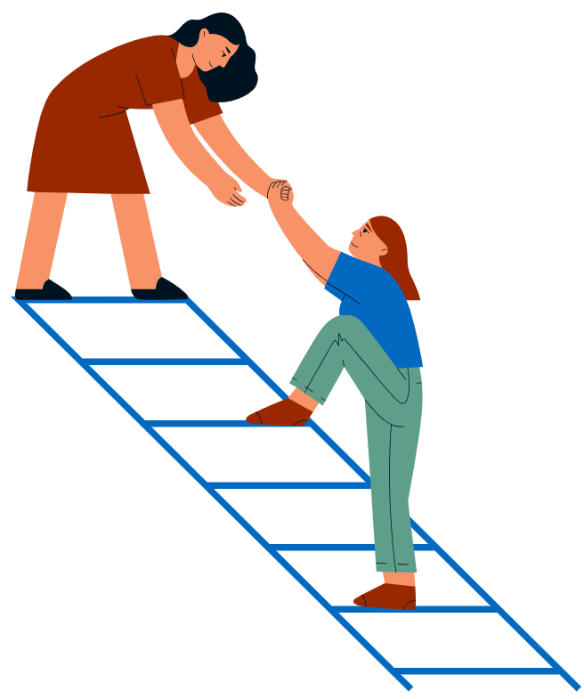

We are a group of organisations that help people who are affected by domestic abuse in Devon.

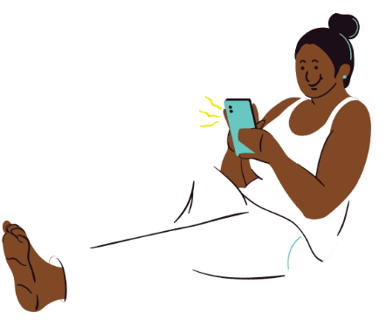

You can contact us:
Email: hello@ddaa.org.uk
Phone: 0808 2816161

What this notice is about
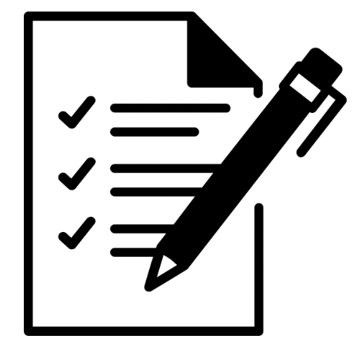
This notice explains:
- What information we collect about you
- Why we collect it
- How we keep it safe
- Who we share it with
- Your rights about your information

Why we collect your information
We collect information so we can:
- Help you and give you the right support
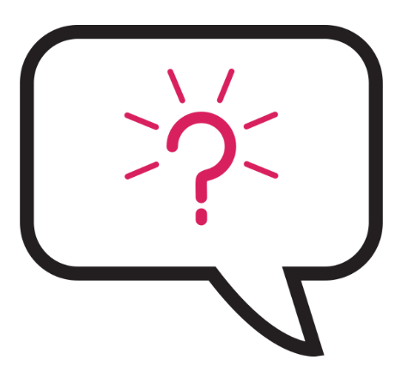
- Contact you if needed
- Make sure everyone can use our services
- Keep people safe, especially adults and children at risk
- Make our website better and easier to use
- Listen to your feedback

We will always ask for your permission to collect and use your information when possible.

What information we collect
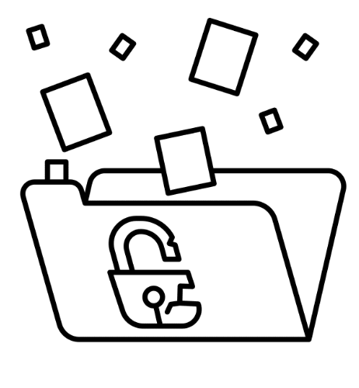
We may collect:
- Information about you like your (and your children’s) name, contact details, address, age and information about your support needs
- Sensitive information (for example, information about your health or safety)
- Information about how you use our website (like your IP address and cookies)
Sometimes, we get your information from other services, but only if you say it is okay.

How we use your information
We use your information to:
- Support you
- Keep you safe
- Improve our services

We will never:
- Sell your information
- Use it for marketing
- Use it to make automatic decisions about you

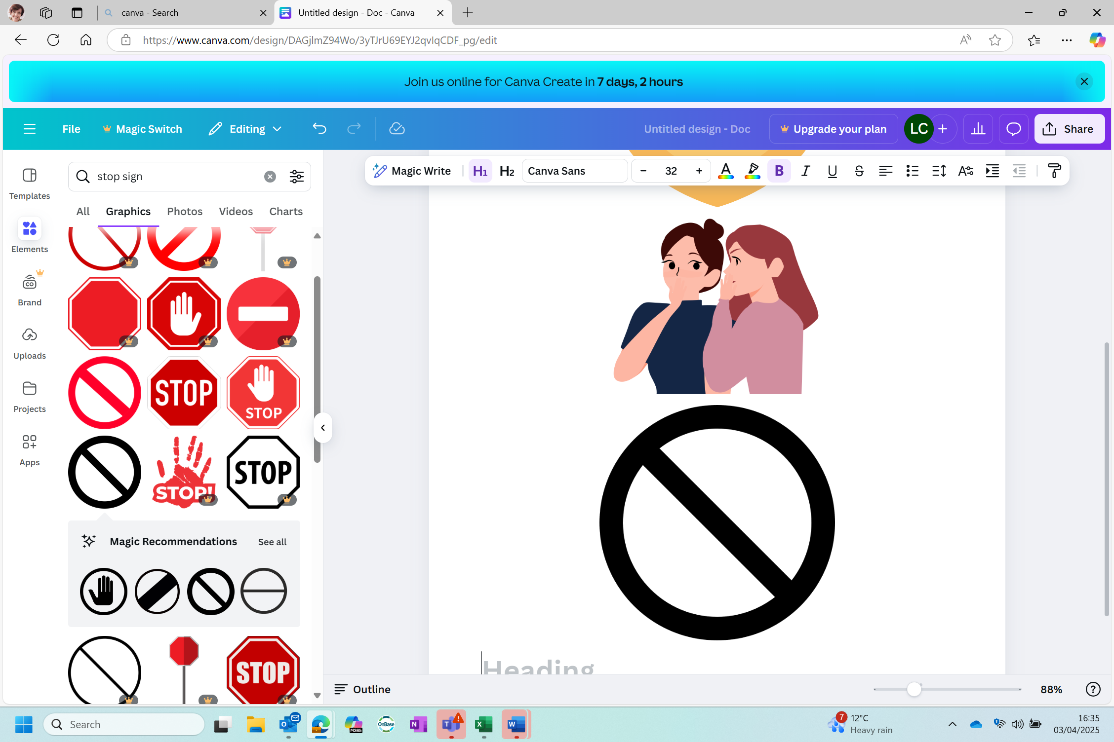
Who we share your information with
We may share your information with:
- Our trusted partner organisations (listed on our website)
- Other services that help you (like health services, housing, schools, police)
- Our secure data system provider
- If the law says we must, for example, if someone is in danger
We will only share your information proportionately and when it is necessary and with your knowledge (unless it is urgent for safety reasons).

How we keep your information safe
We store your information securely in a system called Halo.
Only staff who need to see your information can access it.

How long we keep your information
We will keep your information:
- Only for as long as we need to
- As required by the law

When we no longer need your information, we will delete it safely.
Your rights
You have the right to:
- See the information we have about you
- Ask us to correct wrong information
- Ask us to delete your information
- Tell us to stop using your information
- Change your mind and take back your permission

You can contact us anytime to ask about your information.

If you are unhappy about how we use your information, you can also contact:
The Information Commissioner’s Office (ICO)
Website: https://ico.org.uk
Helpline: 0303 123 1113

Cookies
When you visit our website, we may use cookies (small text files) to:
- Help the website work
- Understand how people use the website
- Remember your choices

You can choose to accept or reject cookies when you visit the website.

Updates
We may change this notice from time to time.
You can always find the latest version on our website.

